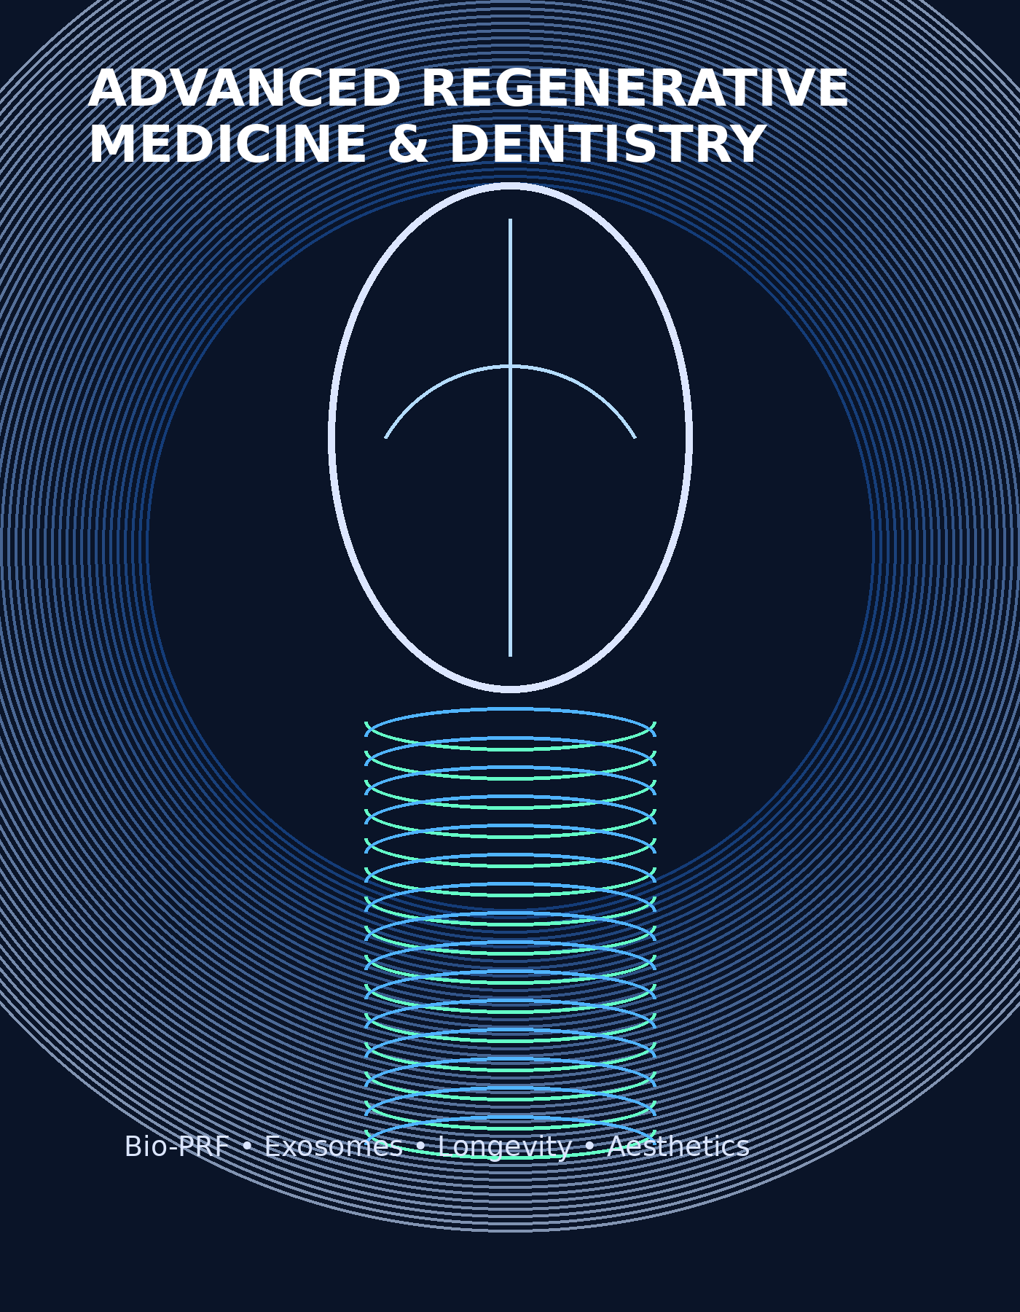
Advanced Regenerative Medicine & Dentistry Mastery Program
Bio-PRF • Exosomes • Longevity Medicine • Regenerative Aesthetics

Program Overview
This advanced educational program is designed for physicians, dentists, nurses, and aesthetic professionals seeking an elevated understanding of regenerative medicine and dentistry. The course explores the art, science, and clinical protocols associated with the predictable use of bio activators including Bio-PRF, exosomes, biologic growth factors, and regenerative approaches used in modern medicine, dentistry, longevity care, and facial aesthetics. This is a limited attendance course with lectures and hands-on components.

Program Schedule
June 11
8:00 AM – 6:00 PM
Interactive Cocktail Party with Faculty: 6:00 PM – 7:00 PM
June 12
8:00 AM – 6:00 PM
Reception Following Presentations
June 13
8:00 AM – 12:00 Noon

Continuing Education & Accreditation
Participants will receive 20 hours of CERP continuing education credit. This program follows recognized continuing education guidelines and is intended for advanced healthcare professionals.

Tuition & Registration
- Physicians & Dentists: $3,200
- Nurses & Aestheticians: $1,600
- Call (404) 906-4510 to obtain a registration discount code
- Limited Attendance Course

Featured Topics
- Advanced Bio-PRF protocols and biologic activation
- Exosome therapy in regenerative medicine and dentistry
- Facial rejuvenation and regenerative aesthetic protocols
- Longevity medicine and tissue regeneration concepts
- Regenerative approaches to implant dentistry
- Bone grafting biology and soft tissue enhancement
- Patient-specific biologic engineering concepts
- Hands-on preparation and clinical implementation techniques

Faculty
Richard Miron DDS PhD
Internationally recognized educator and researcher in platelet-rich fibrin, regenerative dentistry, and biologic healing protocols.
Robert Talac MD PhD
Physician scientist focused on regenerative medicine, tissue engineering, and biologic therapies.
Edward Mills DDS
Restorative and implant clinician emphasizing interdisciplinary regenerative treatment planning and advanced rehabilitation.
Gregory Mackay MD
Physician educator involved in longevity medicine and advanced regenerative medical concepts.
Shahrokh Bagheri DMD MD
Internationally respected oral and maxillofacial surgeon specializing in facial surgery and regenerative surgical reconstruction.
Deborah Moore RN MBA
Authority on laser treatment and facial aesthetics with more than 30 years of experience integrating multidisciplinary aesthetic care.

Registration Form
Please complete the following registration information and submit with payment. Limited attendance registration will be processed on a first-come basis.
Full Name: ________________________________________________
Degree / Credentials: ______________________________________
Office Address: ____________________________________________
___________________________________________________________
Work Phone Number: ________________________________________
Cell Phone Number: ________________________________________
Email Address: ____________________________________________

Registration Category:
□ Physician / Dentist ($3,200)
□ Nurse / Aesthetician ($1,600)

Total Fees: ________________________________________________

Credit Card Information
Name on Card: _____________________________________________
Credit Card Number: _______________________________________
Expiration Date: __________________________________________
CVV Number: _______________________________________________
Billing Zip Code: _________________________________________

Signature: ________________________________________________
Date: _____________________________________________________

Atlanta Institution For Advanced Education
Phone: (404) 906-4510
Fax Registration Form To: (404) 252-3880

